Birds Can Fly or Not
AIM:
To write a Prolog program to determine whether a particular bird can fly or not using facts and rules.
ALGORITHMS:
- Start.
- Initialize the facts about birds.
- Define the birds that can fly, such as sparrow, parrot, pigeon, and eagle.
- Define the birds that cannot fly, such as ostrich and penguin.
- Define the predicate check_fly(Bird) to check the flying ability of a bird.
- If the bird belongs to can_fly(Bird), display “Bird can fly.”
- Else, if the bird belongs to cannot_fly(Bird), display “Bird cannot fly.”
- Otherwise, display “Flying ability of bird is unknown.”
- Define the initial goal using :- initialization(main).
Execute the main predicate to check the flying ability of the given birds.
10.Stop the program using halt.
11.End.
CODE:
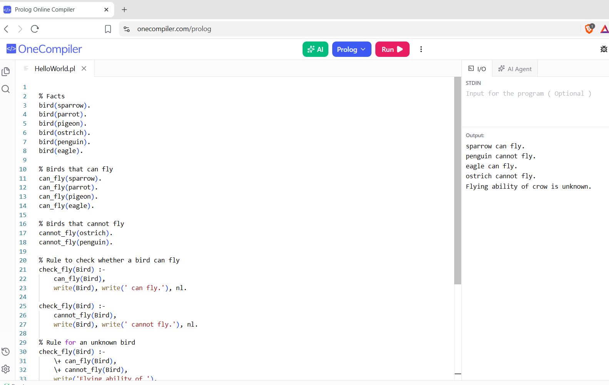

RESULTS:
The program determines and displays whether the specified bird can fly or cannot fly.

